The Grizzlies and the Polar bear

灰熊 and 北極熊

Grizzlies:

學名: Ursus arctos horribilis

Distribution area:

Distributed in western North America, is the most common brown bear in North America.

The habitat of the Grizzlies is currently left in the Alaska region, western Canada and the United States of Idaho, Montana, Washington (state) and other northwestern regions.

There are grizzlies in Yellowstone National Park and Grand Teton National Park.

分布地區:

分布於北美洲西部,是北美最常見的棕熊。

灰熊的棲息地目前僅剩下阿拉斯加地區、加拿大西部及美國的愛達荷、蒙大拿、華盛頓(州)等西北部地區。

在黃石國家公園和大提頓國家公園也有灰熊棲息。

Habits:

Grizzlies often live alone, but in the coastal areas, the Grizzlies gather in streams, rivers, lakes and ponds in the season of salmon spawning.

Female Grizzlies produce 1 to 4 cubs every other year. The weight of each young child is only 500 grams.

習性:

灰熊通常獨居生活,但是在沿海地區,灰熊在鮭魚產卵的季節會聚集在溪流、河流、湖泊和池塘周圍。

雌性灰熊每隔一年生產1至4頭幼崽每頭幼崽重量僅為500克。

Physical capacity:

Female Grizzlies weighing 130 to 200 kg, the average weight of male Grizzlies 180 to 360 kg, the average length of subspecies 198 cm.

Running at speeds of up to 40 kilometers per hour.

身體能力:

雌性灰熊體重為130至200公斤,雄性灰熊平均體重為180到360公斤,整個亞種的平均身長為 198公分。

跑速度可達每小時40公里。

Hazardous species:

The Grizzlies in British Columbia have been up to 25,000 but the number has fallen significantly due to hunting and habitat loss.

In 2008, the number of Grizzlies is estimated at 16014, the current number of Grizzlies in North America is about 55,000.

無危物種:

不列顛哥倫比亞地區的灰熊曾多達25000隻但數量以因為捕獵和棲息地喪失而顯著下降。

在2008年,灰熊的數量估計為16014隻,目前北美洲的灰熊數量大約為55000隻。

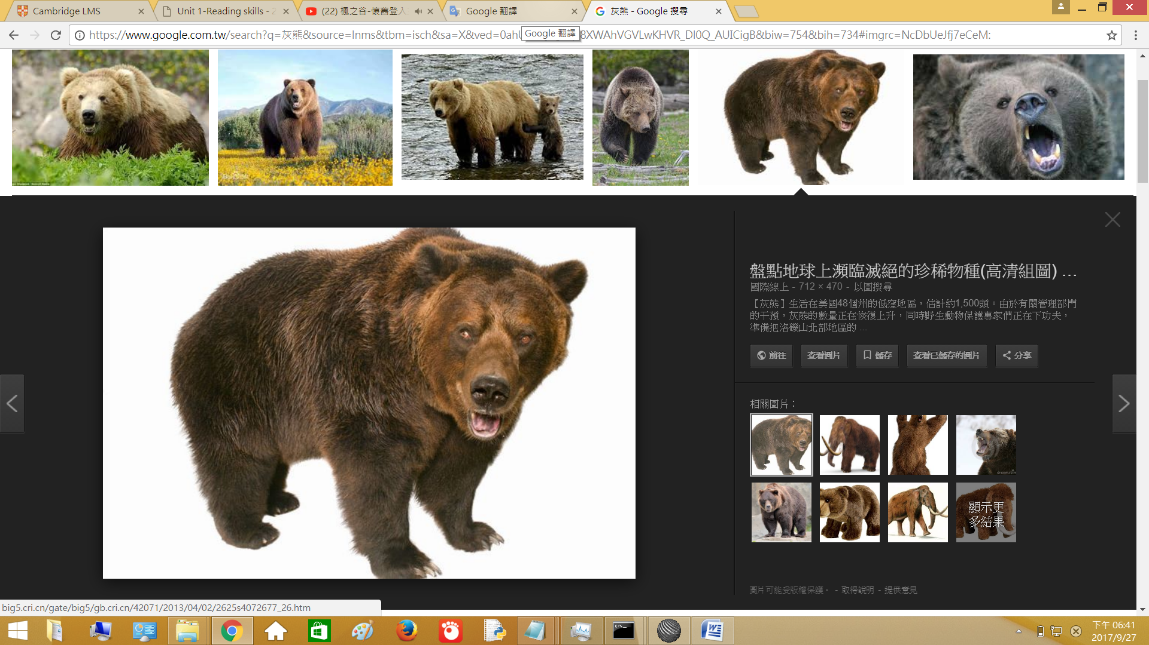

Polar bear:

學名: Ursus maritimus

Distribution area:

Polar bears are animals that can survive in harsh and cool environments, mainly in the Arctic Ocean, near the Arctic Circle.

The IUCN species conservation committee divides the habitat of polar bears into nineteen areas for scientific research purposes, distributed in five countries: the United States, Canada, Russia, Norway, Greenland (Denmark).

分布地區:

北極熊是一種能在惡劣酷寒的環境下生存的動物,其活動範圍主要在北冰洋、即北極圈附近。

國際自然保護聯盟中的物種存續委員會把北極熊的棲息地劃分為十九個地域以做科學研究目的,分布在五個國家：美國、加拿大、俄羅斯、挪威、格陵蘭(丹麥)。

Habits:

Floating ice is a polar bear predatory seal, the survival of the important habitat, so these are the sea ice cloth set area, or the mother polar bear bear a small polar bear breeding cave.

The polar bear is a solitary animal, except for raising the bear's bear, or mating the male and female bear together for two or three weeks together.

Mother bear life, about only 5 births, and only an average of about two, much lower than its ancestors Grizzlies.

習性:

浮冰是北極熊捕食海豹、賴以生存的重要棲地,因此這些皆是海冰布集的區域、或是母北極熊生育小北極熊的的育哺洞穴。

北極熊為獨居性動物,除了養育小熊的母熊、或交配期間公母熊在一起的兩三個星期間外。

母熊一生中,大約只會生產5胎,而隻數平均約兩隻,遠低於其先祖灰熊。

Physical capacity:

Adult male bear upright up to 2.5 meters, the most important weight of 800 kg.

Into Bear Bear bear body size will be much smaller, but also reached about 450 kg, 2.1 meters.

Running speed can reach 40 km per hour, but also good at swimming, to 10 km per hour, 97 km a day tour.

身體能力:

成年公熊直立起來可高達2.5公尺,最重可重達800公斤。

成熊母熊體型會小得多,但也達約450公斤、2.1公尺。

奔跑的時速可以達到時速40公里,也擅長游泳,能以時速10公里、一天游97公里遠。

Endangered species:

The world's polar bears are now less than 25,000.

瀕危物種:

全世界的北極熊現今只剩不到2萬5仟隻。

